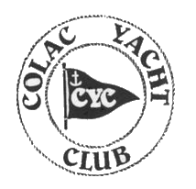 | RL24 Owners Association
2022 RL24
49th National Championship
Monday 10th January – Friday 14th January

Colac Yacht Club
4 Hamilton St, Colac, VIC

NOTICE OF RACE

Colac Yacht Club as Organising Authority on behalf of and in conjunction with the RL24 Owners Association of Australia Inc (RL24 OAofA) invite entries for this regatta to be held on Lake Colac from Monday 10th January 2022 to Friday 14th January 2022 according to the programme herein.

- Rules.
1.1 The Regatta will be governed by the ISAF Racing Rules of Sailing for 2021-24 and Australian Sailing Special Regulations Part 1 2021-24. In the event of any discrepancy in this Notice of Race the provisions of the Sailing Instructions shall take precedence.

1.2 COVID-19 VICTORIAN STATE GOVERNMENT Regulations will apply at the time of the regatta including QR code sign in upon entry into club rooms via the Vic service app. You are not required to be double vaccinated to sail or to enter the club rooms however, when the bar is open it is a state law that anyone within the club rooms must be double vaccinated and proof of such provided when requested. If you are not vaccinated when the bar is open, you must leave the premises immediately.

1.3 All Competitors may be required to display Series or Event sponsor’s name(s)/logo(s) and bow numbers. If required, they shall be affixed and/or worn as prescribed in the Sailing Instructions.

2. Eligibility and Entry.
2.1 The regatta is open to boats of the RL24 class whose owners are financial members of the RL24 Owner's Association of Australia Inc.
2.2 Eligible boats shall enter for the Swing Keel, Drop Keel or Cruising Division by completing and returning the attached entry form via email or mail.
2.3 Entries will be accepted until the close of Registration at 1200 hours on Monday 10th January 2022.
2.4 Boats or skippers shall be required to carry a minimum of $10 million indemnity insurance for the duration of the series.
2.5 All RL24s owners are advised that these National Championships are a Category 7 Event. The Organising Committee reserves the right to request a completed Category 7 Equipment Audit Form.

3. Fee.
The Entry Fees for the RL24 National Championships are:
FEE TYPE | FEE
Early Bird Entry (per boat) until 2359 hours 9th December 2021 | $220-00
Standard Entry (per boat) effective as at 0000hrs 10th December 2021 | $270-00

All Early Bird and Standard Entry Fees are payable by DIRECT DEPOSIT to the RL24 Account (See Entry Form for details.)

4. Measurements and Safety.
4.1 Entrants will be expected to meet the measurement requirements as specified by the RL24 Owner’s Association of Australia. All Entrants are required to hold current Category 7 Equipment Audit Certificates.

5. Sailing Instructions.
5.1 The Sailing Instructions for the Championship will be available from race headquarters at Registration.

6. Schedule of Events.

The Sailing Programme is as follows:
Sunday 9th January 2022
Arrival and setting up at Colac Yacht Club.

Monday 10th January 2022:
0900 hrs: Regatta Registration.
1200 hrs: Briefing session.
1330 hrs: 1st Warning Signal.
Rob Legg Invitation Series Races 1, 2 & 3 (back-to-back).

Tuesday 11th January 2022:
1330 hrs. 1st Warning Signal.
Championship Heats 1 and 2 (back-to-back)

Wednesday 12th January 2022:
1100 hrs. Re-sail Opportunity
1330 hrs. 1st Warning Signal.
Championship Heats 3 and 4 (back-to-back)
1800 hrs. AGM Colac Yacht Club (club rooms)

Thursday 13th: January 2022:
1100 hrs Re-sail Opportunity
1330 hrs. 1st Warning Signal.
Championship Heats 5 and 6 (back-to-back)

Friday 14th January 2022:
1100 hrs. 1st Warning Signal.
Championship Heat 7.
(Resail opportunity if required, after end of Heat 7)
1830 hrs – Presentation Dinner at Colac Yacht Club (club rooms)

6.1 Four (4) races shall constitute the series.
6.2 A maximum of three (3) races can be sailed per day.

7. Racing Area and Courses.
7.1 Races will be conducted on Lake Colac on courses as described in the Sailing Instructions.

8. Scoring.
8.1 The Low Point scoring system, RRS Appendix A 4.1 will apply except that first place in each race will score 0.75 point. A minimum of 4 races is required to make up the RL24 National Championship event.
i) When fewer than five races have been completed, a boat’s series score will be the total of its race scores.
ii) Where five or six races are completed, a boat's worst single score may be excluded.
iii) Where seven races are completed, a boat's two worst single scores may be excluded.

8.2 The divisions for this National Championship will be:
i) Swing Keel.
ii) Drop Keel; and
iii) Cruising.

If there are insufficient entries to form a Swing Keel Division (Minimum 3 boats) and insufficient entries to form a Drop Keel Divisions (Minimum 3 boats), all RL24s will sail together, and elapsed times will be corrected using Australia Sailing’s ATYSB’s Class Based Handicaps (i.e. DK = 0.760; SK = 0.725).

9. Personal Buoyancy.
9.1 All competitors shall always wear personal flotation devices whilst afloat and outside the cabin.

10. Safety.
10.1 The Safety Category applicable to this series is Australia Sailing Special Regulations Part 1 Section 2.01.8 Category 7.
10.2 At the discretion of the Race Officer, based on safety reasons, the Race Officer may abandon the stated race programme (NoR) because of foul weather.
When the wind strength consistently exceeds 25 knots for a 5-minute period within a 60 minute period immediately before the normal starting time of the first heat to be sailed each day, then that heat will be postponed or abandoned. A similar decision will be made regarding the second heat to be sailed on that same day at 1 hour after the advertised starting time for the first heat. No warning signal will be given after 4.30pm. When one or both races are abandoned for that day, the race(s) can be resailed on later days of the sailing programme.
Races will not be started in less than an average of 4 knots of wind on the course area. This lower wind limit may be higher if there is a strong current in the racing area.
10.3 In addition, the following will apply:
3.24.3(b) Outboard motors shall be mounted in the normal operating position but may be retracted while sailing.
3.24.6 A minimum of 9 litres of fuel must be carried at the start of each race.

11. Radio Communication.
11.1 Except in an emergency, a boat that is racing shall not make voice or data transmissions and shall not receive voice or data communication that is not available to all boats. This includes Mobile phone communications.

12. Decisions of Protest Committee.
12.1 A protest committee will be appointed for the 2021-2022 Australian RL Championship in accordance with RRS 91.

13. Prizes.

- Drop Keel Champion (Rob Legg Perpetual Trophy).
- Swing Keel Champion (Rob Legg Perpetual Trophy).
- Handicap Trophy (Perpetual Trophy)
- Rob Legg Invitation Series Trophy (Perpetual Trophy)
- Cruising Division Champion- depending on numbers of entries.
- Coolibah Trophy (Perpetual Trophy)
- Oldest Skipper Flag (Perpetual Trophy)
- Toad of Barmera Trophy (Perpetual Trophy)
- Other prizes may be awarded as determined by the RL24 OAofA.

14. Disclaimer of Liability.
14.1 Competitors participate in the regatta entirely at their own risk. See RRS 2021-24 Rule 3, Decision to Race. It is the Competitor's decision to enter the Regatta or to start or continue in any race. Neither RL24 OAofA nor the Colac Yacht Club will accept any liability for material damage or personal injury, or death sustained in conjunction with or prior to, during, or after the regatta.

15. Insurance.
15.1 All boats shall include details of current third-party insurance to the cover value of AUD$10,000,000.00 on the entry form. The completion, by a competitor, and acceptance, by the organising authority, of an entry form shall constitute acknowledgment by the competitor that such cover is valid and in place for the period of the Regatta. Each boat shall provide evidence of currency of Insurance Cover with the Entry Form.

16. Measurement.
16.1 The RL24 OAofA reserves the right to inspect, measure or check hull, spars, sails, and safety equipment of any yacht at any time before or after any heat during the series. Each boat will have a valid measurement certificate and maybe required to produce it.

17. Mandatory Sign on / sign off.
17.1 For each race or race session each competitor intending to race shall personally “sign-on”, by completing the appropriate details on the “sign-on/off” sheet located in the Colac Yacht Club rooms prior to the warning signal of the race session. Failure to comply with this Sailing Instruction will result in a boat scoring DNC for the races of the session without a hearing. This changes RRS 63.
17.2 All boats shall “sign-off” upon returning to shore by completing the appropriate details on the “sign-on/off” sheet located in the Colac Yacht Club rooms no later than the end of protest time for that day. Failure to comply with this Sailing Instruction will result in a boat scoring DNF for the races of the session without a hearing. This changes RRS 63.1.
17.3 Sign on / Sign off ashore is automatically accepted for one or more races of each “on water” session.

18. Presentation Dinner.
18.1 Presentation Dinner will be held in main room, Colac Yacht Club on Friday 14^{h} January 2022 at 1830 hrs.

19. Further Information.
19.1 For further information, please contact the following:
President: Wayne Hill its.wayne@hotmail.com Mob: 0418 508167
Colac Yacht Club: Adam Chambers adamchambers80@gmail.com Mob:0411120996
Publicity Officer: Darryn Dyer darryndyer@hotmail.com Mob 0409 338916

20. Address.
COLAC YACHT CLUB. 4 Hamilton St, COLAC. 3250

RISK WARNING.

This RISK WARNING is issued jointly by the COLAC YACHT CLUB, and Marine safety act 2010 (Vic) and marine safety regulations 2012 (Vic) pursuant to the Civil Liability Act 2002 to all persons wishing to participate in the sailing activities conducted by Colac Yacht Club.

Participants are warned that, regardless of the precautions, which might be taken by reasonable and experienced persons, sailing can be a dangerous pursuit and participants are exposed to significant risk of property damage, physical harm and possibly death.

As an indication, these risks may include, but are not limited to:

- The extremes of weather and sea conditions.
- The potential that control of vessels may be lost, resulting in collision with objects and other vessels.
- The sudden movement of the vessel at any time and the possibility that participants may fall or be thrown overboard, resulting in drowning.
- The possibility that participants may be injured by equipment on the vessel.
- The absence of immediate medical care and the likelihood that significant delays may occur before medical care is available.
- Exposure to the elements for extended periods.

Participants are also advised that although Colac Yacht Club Inc. is covered by third party liability insurance, this cover DOES NOT extend to participants. Any participant who considers they have a need for insurance must make their own private arrangements with an insurer. A personal accident insurance policy is available with subscription to membership of Australian Sailing.

Facilities.
Colac Yacht Club welcomes all entrants and their supporters to use their facilities.

Coffee and Snacks are available from 11.00am daily.

Launching ramps are available at Colac Yacht Club and the club tractor will be available for launching and retrieving after each day’s sailing (tractor manned by club official)

Trailer parking areas will be set out upon arrival at CYC.

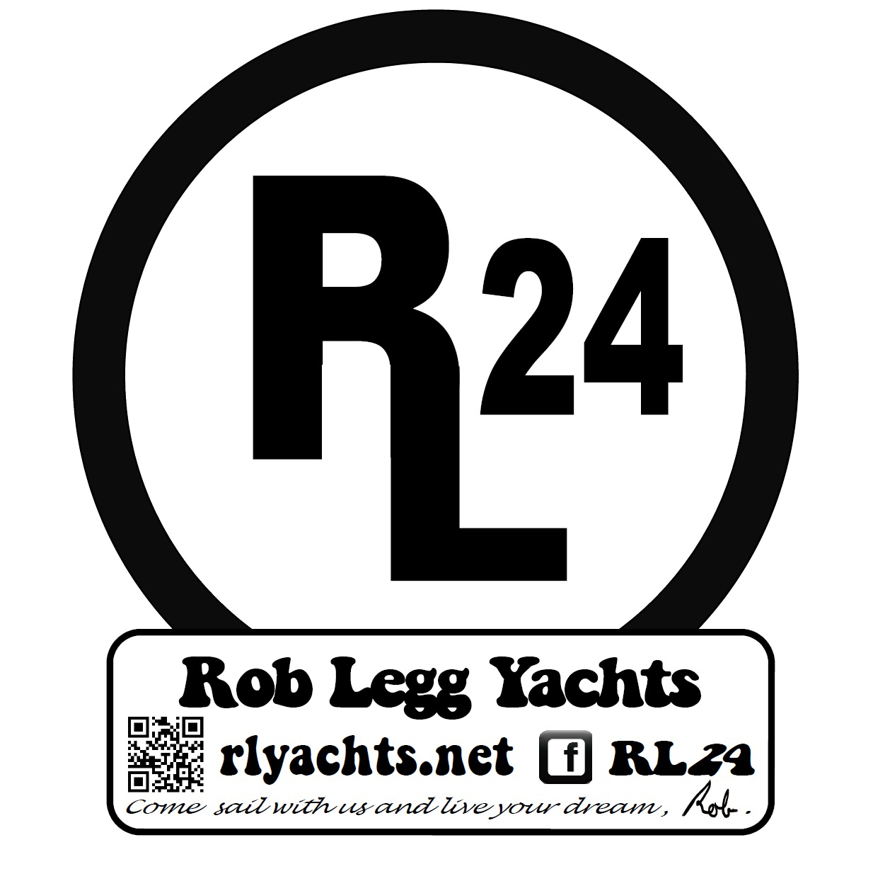 | RL24 OWNER’S ASSOCIATION  OF AUSTRALIA INC.  49th NATIONAL CHAMPIONSHIPS  Monday 10TH January – Friday 14TH January 2022  COLAC YACHT CLUB

ENTRY FORM
Owner’s Name:.................................................................................................................
Owner’s Address………………………………………………………………………...
…………………………………………………………….... Post Code ………………
Owner’s Phone (H)......................................... (Mobile) ....................................................
E-Mail (if available)...........................................................................................................
Skipper’s Name:.................................................................................................................
Boat Name:............................................................................ Sail Number: ..................

Division Entered (Circle one):
SWING KEEL DROP KEEL CRUISING

Aust Sailing National Membership No. ............................................

Insurance Provider and policy number:……………………………………………………
Please attach photocopy of policy showing amount covered for. (Valid third-party liability min. $10 million)
Entry Fee: Early Bird: $220.00 Due on or before 9th December 2022.
Standard Entry: $270.00 Due on or before 10th January 2022.
How to pay: Direct Deposit - RL24 Owners Assn. of Australia BSB 063-510 Acc#10135552. Please use your boat name and sail number as a reference.
Or: Cheque - payable to the RL24 Owner’s Association of Australia Inc. & forwarded to The Secretary of the RL24 Owner’s Assn. of Australia, 49a Whimbrel Avenue, Lake Heights NSW 2502.
DIRECT DEPOSIT is the preferred method of payment.
I agree to compete in compliance with recognized principles of sportsmanship and fair play. I accept that competitors participate in this Regatta entirely at their own risk. Further, I understand that neither the Colac Yacht Club nor the RL24 Owners Association of Australia Inc. will accept any liability for material damage or personal injury, or death sustained in conjunction with or prior to, during or after the Regatta.
My RL24 complies with i) the Class Association’s rules and specifications. YES / NO (circle one).
And ii) with the AS Special Regulations valid to June 30, 2024 Part 1; Category 7. YES / NO (circle one).

.......................................................(Owner) .........................................(Skipper - if not owner)
Notice of Race CYC INDEMNITY Declaration.

Indemnity Declaration for Regatta Competitors at Colac Yacht Club for Boat/Number: __________________________
I, in my capacity as the adult entrant, Parent, Legal Guardian or Custodian of the Skipper/Crew of the boat referred to in the Entry Form:
1. acknowledge that this entry is made subject to the conditions set out in the Notice of Race and Sailing Instructions as may be amended by the Organising Authority.
2. acknowledge that all racing conducted by the Organising Authority will be governed by the rules and regulations specified in the Notice of Race and Sailing Instructions, as they may be amended.
3. warrant to the Organising Authority that:
a. I have read and understand the Notice of Race and Sailing Instructions and that, if they are amended by the Organising Authority, I will read any amendment.
b. I have provided a copy of and brought the Notice of Race and Sailing Instructions to the attention of the crew of the boat (if any) and have satisfied myself that the crew of the boat (if any) understand the Notice of Race and Sailing Instructions.
c. I will provide a copy of and bring any amendment to the Notice of Race and Sailing Instructions to the attention of the crew of the boat (if any) and will satisfy myself that the crew of the boat (if any) understand any amendment.
d. the boat referred to in the Entry Form:
(i) is and has been properly maintained; and
(ii) is structurally sound and seaworthy (including hull, spars, rigging sails and all gear);
(iii) is suitable for the event or events referred to in the Entry Form;
(iv) carries all necessary and required equipment (including emergency equipment).
e. I and the crew of the boat (if any) will, while participating in the event or events referred to in the Entry Form, comply with the rules of this declaration.
f. I and the crew of the boat (if any) are aware of ISAF Fundamental Rule 3 “Decision to Race” which states “The responsibility for a boat’s decision to participate in a race or to continue racing is hers alone”.
g. I and the crew of the boat (if any) are all individually aware of and conversant with the risks involved in the sport of sailboat racing.
h. I and the crew of the boat (if any) are all individually aware that the participation in a race is entirely at our own exclusive risk and that the Organising Authority excludes all liability in the manner referred to in the Notice of Race.
i. I and the crew of the boat (if any) acknowledge and accept the risks associated with participating in the event or events referred to in the Entry Form including:
(i) any risks referred to the Notice of Race; and
(ii) the seaworthiness or otherwise of any boat participating in the event or events
(iii) the participation, including negligent participation, by persons in the event or
(iv) the defaults, acts and omissions of persons, including negligent defaults, acts referred to in the Entry Form; events referred to in the Entry Form; and omissions of the Organising Authority and its officers, employees and agents and the crews of other participating boats.
j. I and the crew of the boat (if any) acknowledge and accept that the Organising Authority:
(i) does not and cannot control, diminish, or affect the perils of the sea;
(ii) is not in a position to take precautions against the risk of harm to persons
(iii) may not be in a position to provide advice, assistance or support to boats and
k. I and the crew of the boat (if any) release, hold harmless and indemnify the Organising Authority and its officers, employees and agents from all liability any of those persons has to the owner/skipper or any crew member on the boat, or to any person claiming through or under any such person, arising from the loss of life or injury to persons, or loss of or damage to property, howsoever caused, including by negligent act omission, arising out of or relating to:
(i) participation by the boat or any other boat in the event or events referred to in
(ii) the conduct or courses of races in any respect including any act or omission arising from the perils of the sea; and crews during the course of the event or events referred to in the Entry Form; and/or (whether reasonably foreseeable or not) causing or relating to loss of or damage to any boat or the death of or injury to any person.
l. I and the crew of the boat (if any) indemnify the Organising Authority and any officer, employee or agent in respect of any costs in respect of any assistance that may have to be rendered to the boat or crew (if any) in respect of any rescue including if the boat becomes disabled or any person is overboard or for any other reason.
m. I and the crew of the boat (if any) acknowledge and agree that the contract formed by the acceptance of the Entry Form by the Organising Authority is governed by the law of Victoria;
4. declare that the information in the Entry Form is correct.

(PRINT NAME) _________________/______________________(SIGN)______________/______________ Date: ______________
NOTE: Parent, Legal Guardian, or Custodian to also sign for all entrants under the age of 18.
I, ____________________________________ Of (ADDRESS)_______________________________________________________
being the parent, legal guardian, or custodian of (Entrant under 18) __________________________________________________
Consent to him/her/them participating in this regatta and indemnify the Organising Authority.
Signed: _____________________________________________ (Parent, Legal Guardian, or Custodian) Date: ______________.

